数学与系统科学研究院学术报告
报告题目：Vector Control Lyapunov Functions for Nonlinear Control Design
报 告 人：Zhongping Jiang, Polytechnic Institute of New York University
时间地点：10:10-11:10AM, August 19, 2013, Room 712, Siyuan Building
摘 要：
In this talk we will introduce the concept of vector control Lyapunov functions for the design of globally stabilizing feedback laws for nonlinear systems.
It is shown that the existence of a vector control Lyapunov function is a necessary and sufficient condition for the existence of a smooth globally stabilizing feedback.
Applications to nonlinear systems are provided: simple and easily checkable sufficient conditions are proposed to guarantee the existence of a smooth globally stabilizing feedback law.
Connections with the cyclic-small-gain theorem are explored. The obtained results are applied to the problem of the stabilization of an equilibrium point of a reaction network taking place in a continuous stirred tank reactor.
报告人简介：
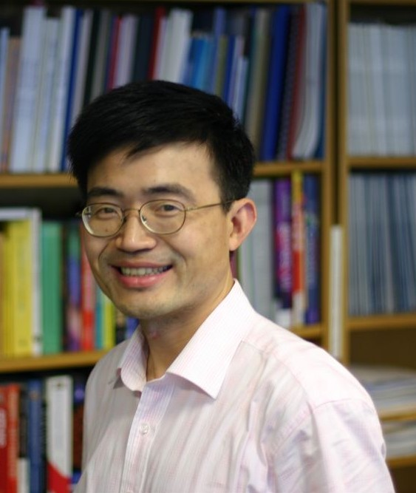
Zhong-Ping JIANG received the B.Sc. degree in mathematics from the University of Wuhan, Wuhan, China, in 1988, the M.Sc. degree in statistics from the University of Paris XI, France, in 1989, and the Ph.D. degree in automatic control and mathematics from the Ecole des Mines de Paris, France, in 1993.

Currently, he is a Professor of Electrical and Computer Engineering at the Polytechnic Institute of New York University. His main research interests include stability theory, robust, adaptive and distributed nonlinear control, adaptive dynamic programming and their applications to information, mechanical and biological systems. He is coauthor of the book Stability and Stabilization of Nonlinear Systems (with Dr. I. Karafyllis, Springer 2011).

Dr. Jiang is an Editor for the International Journal of Robust and Nonlinear Control and has served as an Associate Editor for several journals including Mathematics of Control, Signals and Systems (MCSS), Systems & Control Letters, IEEE Transactions on Automatic Control, European Journal of Control and Science China: Information Sciences. Dr. Jiang is a recipient of the prestigious Queen Elizabeth II Fellowship Award from the Australian Research Council, the CAREER Award from the U.S. National Science Foundation, and the Young Investigator Award from the NSF of China. Recent awards recognizing his research work include the Best Theory Paper Award (with Y. Wang) at the 2008 WCICA, and the Guan Zhao Zhi Best Paper Award (with T. Liu and D. Hill) at the 2011 CCC, and the Shimemura Young Author Prize (with his student Yu Jiang) at the 2013 Asian Control Conference in Istanbul, Turkey.
Dr. Jiang is a Fellow of IEEE (elected in late 2007) and is recently elected a Fellow of IFAC.

